Activity 21

NAME : Sharatha sree R COURSE : Mobile Computing
Reg No : 192421033 COURSE CODE: ITA0301

In Figma, design a mobile app interface that prioritizes user connectivity and convenience. Highlight key elements.

Aim:
To design a mobile app interface that prioritizes user connectivity and convenience. Highlight key elements.

Procedure:
- Create a file
- Add The First Frame
- Add Shapes
- Add Text
- Create The Second Frame
- Add Prototyping


Step By Step Procedure : Interface Of Experiment

Menu Page:

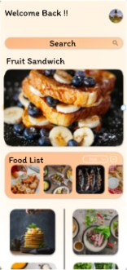

Final Step:
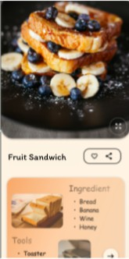

Prototype:

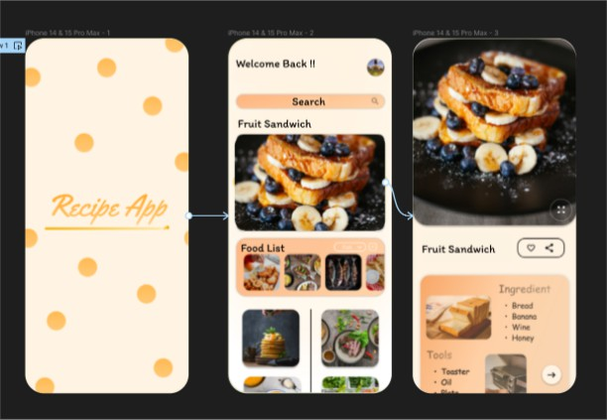

Result:

Hence the mobile app interface that prioritizes user connectivity created and executed successfully.

